Read the Case on next 4 slides and
answer the five(5) questions that follow.
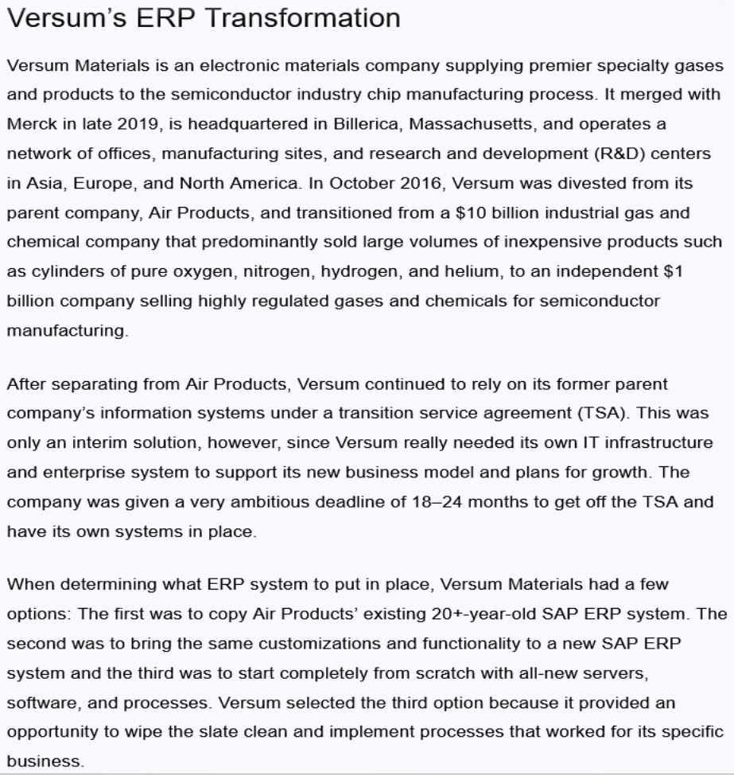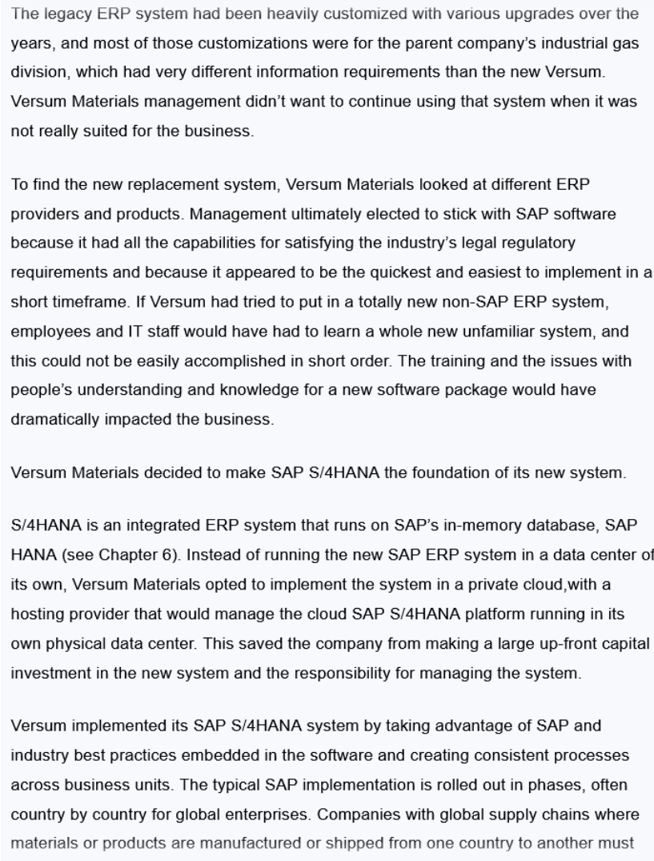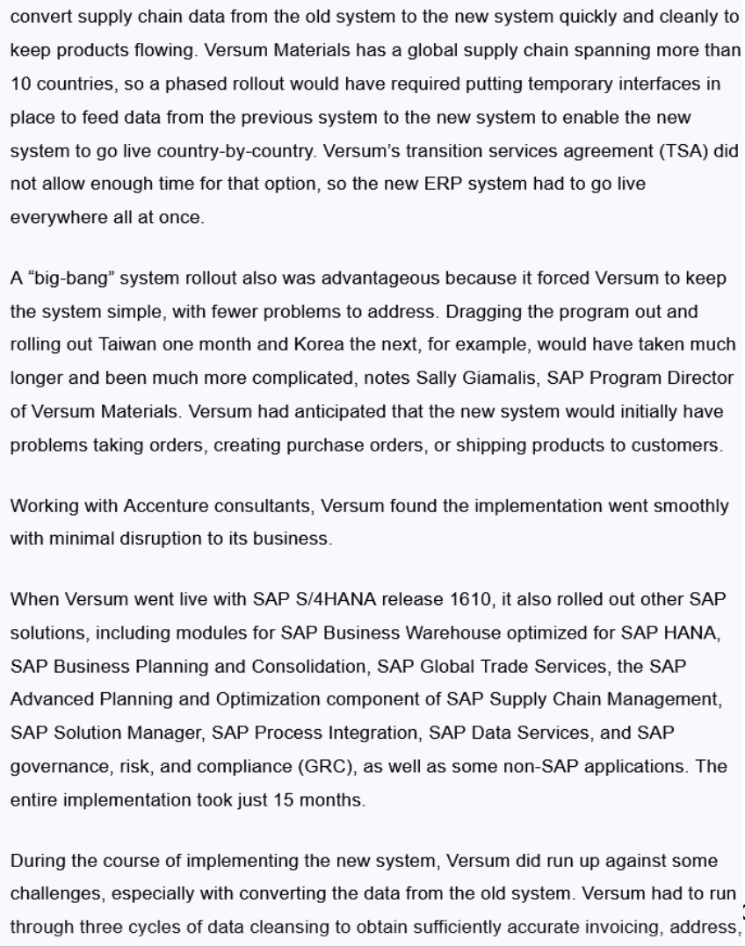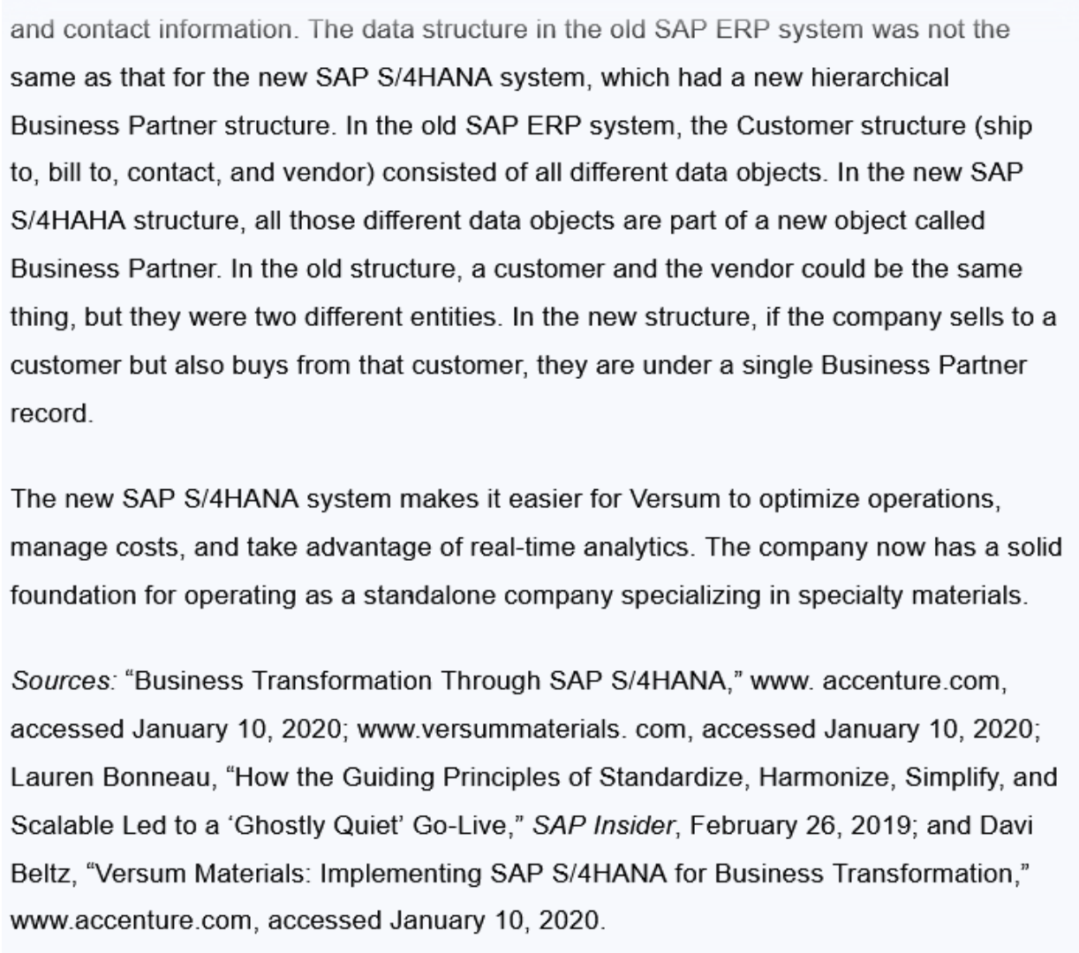
Questions To Answer For Homework
1. Define the problem in this case study.
2. What management, organization, and technology factors contributed to this problem?
3. Was the SAP S/4 HANA SaaS solution a good one for Versum? Explain your answer.
4. What challenges did Versum encounter implementing the new system?
5. How did the new system change the way Versum ran its business?

